**Lesson06 using Jump Server**

**Notes: -**

**1-in Azure virtual network we have multiple subnets each one contains resources with ASG like the first subnet contains Azure VM and the second subnet contains Azure database , so in order to access the azure VM that hosted web app you can access through RDP , http ,and the second azure that hosted database app you can also access through RDP , http**

**(but this make security concern , since it will make difficult maintenance policy restriction plus apply new inbound role on each azure subnet)**

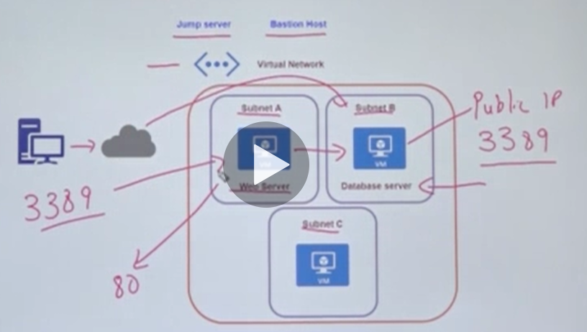

**2-so the solution is by using jump server , its separate server that associated with public IP address and the other subnets like App server and database server is associate only with private IP address and the only way to connect through only with the RDP Subnet C and with it will connect with the RDP**

**(this is called jump server which is the middleware between the other subnets that hold azure resources and the client that request these resource)**

**The advantage is you have only to add the policies on this subnet**

